**Automation Testing – Assignment**

**1.Test Cases for To-Do Functionality**

Detailed Test Cases for To-Do Functionality and the Priority for each Test Cases is given and which Test Cases is suitable for Automation is also mentioned in below:

<https://docs.google.com/spreadsheets/d/15fTpAzlNnTc2iUzckxSczA6Ff0J4uPNQ/edit?usp=drive_link&ouid=102053330549656622953&rtpof=true&sd=true>

**3. Bug Report:**

**Bug 1: Items show as completed when drop down icon is clicked – Functionality Bug**

* **Title:** Drop-Down Icon displays the status of all items as completed.
* **Steps to Reproduce:**
  + - Go to Todo website
    - Add items as required
    - Click the Drop-Down icon beside the input field.
* **Expected Result:** Once, the Drop-Down icon is clicked, the created items should show in list.
* **Actual Result:** The items are changed to completed.
* **Screenshot:**

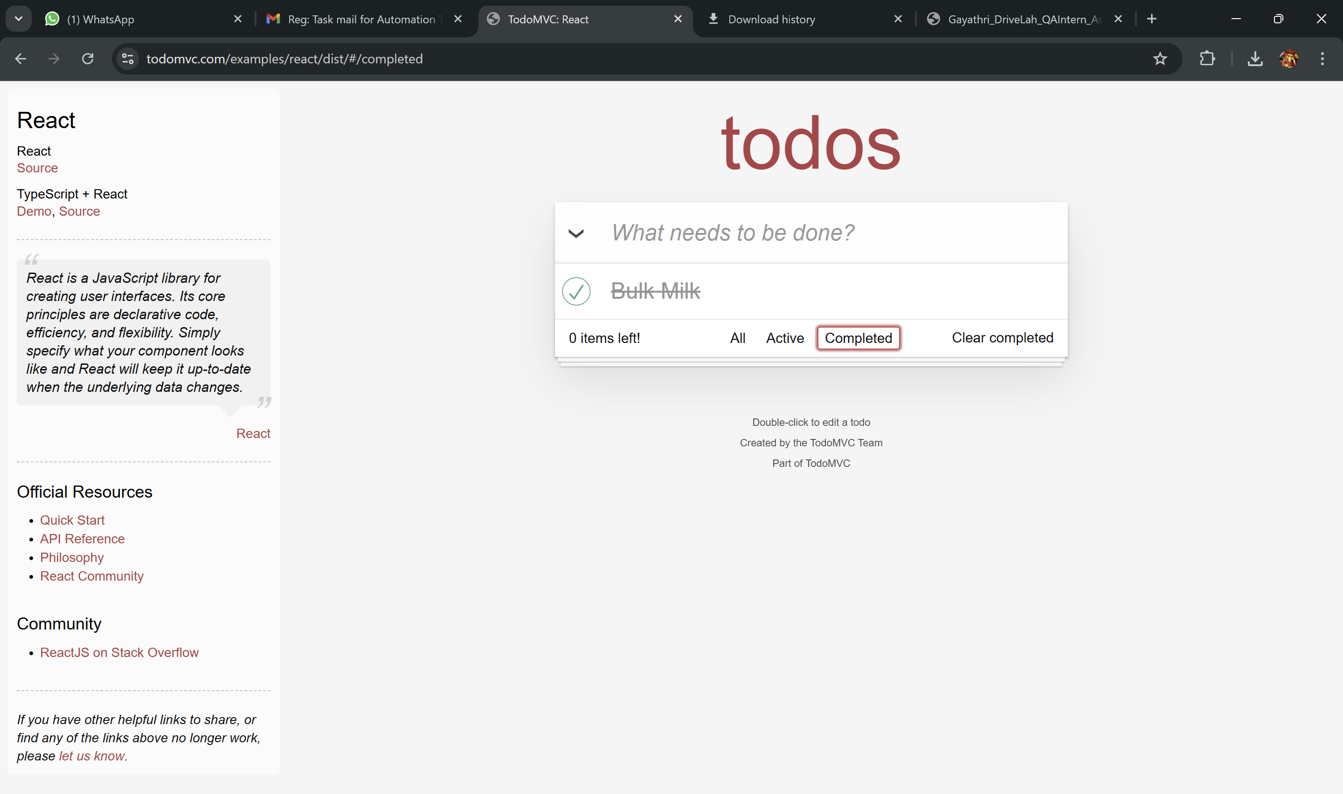

**Bug 2: Sub – items are created as Main items**.

* **Title:**  When Sub-items are items are added, it does not get added.
* **Steps to Reproduce:**
* Go to Todo Website
* Add main item
* Then, add Sub-item in the Main item
* **Expected Result:** When Sub-items are added to the Main item, it should reflects as sub-item.
* **Actual Result:** Sub -items are not created, but results as Main-Item.
* **Screenshot:**

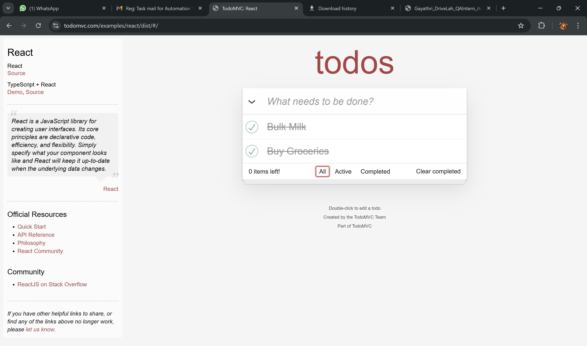

**Bug3: Inappropriate Exclamatory Tone in “0 items left!” Message on To-Do List**

* **Title: Inappropriate Exclamatory Tone in”0 items left!” Message on To-Do list**
* **Steps To Reproduce:**
* Go to Todo website
* Add two items (e.g. Buy Groceries, Buy milk)
* Mark both items as complete
* Observe the message displayed in the footer.
* **Expected Result:** The message should display a neutral, informative tone
* **0 items left.**
* **No active tasks.**

This ensures the tone is appropriate for a completed task summary.

* **Actual Result:** The message reads:

“0 items left!”

